Message from
Education Minister Mike Bernier

October 4, 2016

Dear Parent,

I’m writing today to ask you to share your opinions with the Ministry of Education as we work to update student reporting in kindergarten through Grade 9. Students in these grades are experiencing B.C.’s new curriculum in classrooms in every part of the province.

We are adapting the curriculum in B.C. schools so kids learn the skills they need to succeed in our changing world. This means we also need to develop a new reporting approach. Right now the progress of your child is reported in many different ways, including report cards, parent teacher meetings, and regular student/parent/teacher check-ins.

Reporting is all about keeping parents like you informed, and we want you to tell us HOW you want to be informed and keep track of your child’s progress. Until February 28 next year you can submit your thoughts online at engage.gov.bc.ca/yourkidsprogress.

As well, community meetings will be held in 10 communities across the province over the coming months so parents can ask questions and share their input. Check the website for times and locations as they are scheduled.

The ultimate goal of this engagement is to develop a student reporting process that gives families a deeper understanding of their child’s progress at school through timely and comprehensive information. We’ll gather the feedback and share our plan next June.

Our education system is one of the most highly ranked in the world. Students are finding success in music, in academics, in sports – and in every subject in between. Together parents, teachers, and the education system are making sure we build on that for an even better tomorrow.

For more details on our new curriculum, please visit www.curriculum.gov.bc.ca.

Thanks for your help,

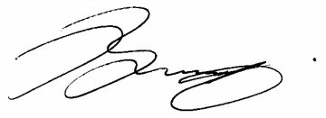

Mike Bernier
Minister of Education

